A000-Afr-Gabon-Tshogo-Door with crosses-early 20th c

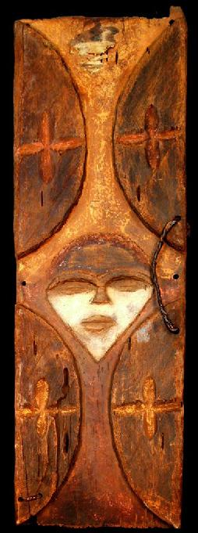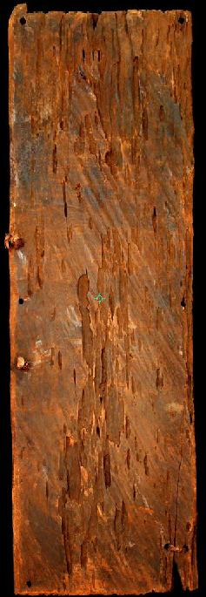

Figs. 1-2. Afr-Gabon-Tshogo-Door with crosses-early 20th c

Case No.: 6

**Accession No.**

**Formal Label:** Afr-Gabon-Tshogo-Door with crosses-early 20th c

**Display Description:**

**LC Classification:**

**Date or Time Horizon:**

**Geographical Area:**

**Map:**

**GPS coordinates:**

**Cultural Affiliation:**

**Media: wood, kaolin**

**Dimensions:** 37.795 in

**Weight:** 5.04 lbs

**Condition:**

**Provenance:**

**Discussion:**

**References:**